Report to |  | On |  |  | 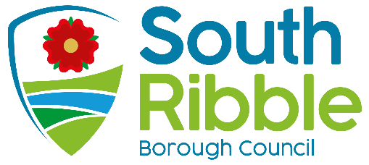
Council |  | Wednesday, 19 May 2021
Title |  |  |  | Portfolio Holder |  |  | Report of
Returning Officer Report |  |  |  | Not applicable |  |  | Returning Officer / Chief Executive

Is this report confidential? | No

Purpose of the Report
- To report to Full Council those people that were duly elected as councillors for the Longton and Hutton West ward by-election and St Ambrose ward by-election on 6 May 2021.

Recommendations
- That the report be noted.

Corporate outcomes
- The report relates to the following corporate priorities:

An exemplary council |  | Thriving communities
A fair local economy that works for everyone |  | Good homes, green spaces, healthy places

Background to the report
- By-elections for the vacant council seats in the Longton and Hutton West ward and St Ambrose ward were held on 6 May 2021.

Persons Elections
- The following persons were duly elected:

Longton and Hutton West ward | Julie Ann Buttery
St Ambrose ward | Kath Unsworth

Risk
- There are no risk implications as a result of this report.

Equality and diversity
- There are no equality and diversity implications as a result of this report.

Air quality implications
- There are no air quality implications as result of this report.

Comments of the Statutory Finance Officer
- There are no comments from the Statutory Finance Officer.

Comments of the Monitoring Officer
- This report constitutes best practice.

Background documents
There are no background papers to this report.

Appendices
There are no appendices to this report.

Gary Hall
Returning Officer / Chief Executive

Report Author: | Email: | Telephone: | Date:
Darren Cranshaw (Shared Services Lead - Democratic, Scrutiny & Electoral Services) | dcranshaw  @southribble.gov.uk | 01772 625512 | 07/05/21

